A Description and Study of Intermediate Student Programmer Errors

Danny Kopec, Gavriel Yarmish, Patrick Cheung

Brooklyn College Computer Information Science 2900 Bedford Ave

Abstract. To date there has been considerable investigation into the study of novice programmer errors. The research has analyzed both syntactic and semantic errors. However, the next level of programmers, who make more sophisticated errors, the internmediate level programmers, have been somewhat neglected. In this paper, we focus on the nature of the errors which intermediate level programmers make. The basis of our study is the semantic approach. Here, we the study problems which require more difficult program constructs such as nested loops, arrays, recursion, and functions.

Keywords: Programmer errors; Semantic Analysis; Plans and Goals; Advanced Novice Programmers; Intermediate Programmers

1. Introduction

Advances in computer technologies are not only being exploited by business and industry, but they are also now commonly used in the home. Applications such as: on-line banking, on-line shopping, and even typing research papers are common. People use diverse software and computer applications to reduce redundancies in work and to enhance their job performance. Given the ubiquitous nature of computer software, it is reasonable to ask who develops and designs the applications and software we have become so dependent on? Without programmers to design software applications for end-users, people would not be able to automate tasks as they do with computers today. Programmers use both skill and experience in the development of powerful computer applications and software programs. Nevertheless, end-users may encounter errors when they use the computer program(s). What misunderstandings may be responsible for programmer errors?
James Spohrer, Elliot Soloway and Edgar Pope are the pioneers in the study of novice programmer errors since the 1980’s. They make use of GAP (Goals and Plans) Trees, which they used to analyze the nature of errors that novice programmers make [1]. This paper focuses the study of the kind of errors students taking the second programming course in C, (called “Advanced Programming in C, CIS 15”) at Brooklyn College. For the purposes of our study we have deemed these students “intermediate level programmers” and we are trying to analyze the programming errors they make on their midterm and final exams. The more educators learn about the nature of problems that students have trouble with, the more effective educators can be in teaching their students [2].

2. Previous Research

Spohrer, Soloway and Pope[1] use the relationship between goals and plans to investigate the different types of errors that novice programmers make. We describe their scheme. A programming plan is an approach or strategy for implementing a goal. “The relationship between programming goals and plans is that a goal can be achieved by any one of a number of different plans. A plan may give rise to more than one sub goal. [1]” There are two types of GAP trees: Inferred GAP Tree and Solution Subtree of GAP Tree. An inferred GAP Tree corresponds to multiple plans that can be used to achieve the goals necessary to solve the problem. A Solution Subtree refers to one particular set of plans that can be used to achieve the goals of the problem. A tree representation of programming plans and goals is shown at Figure 1. In this figure the problem solution consists of three main goals. Each goal has two possible plans which represent two different ways of achieving the same goal, which corresponds to reaching the same solution. Each of these plans has three sub goals, each of which in turn can be achieved with another plan.

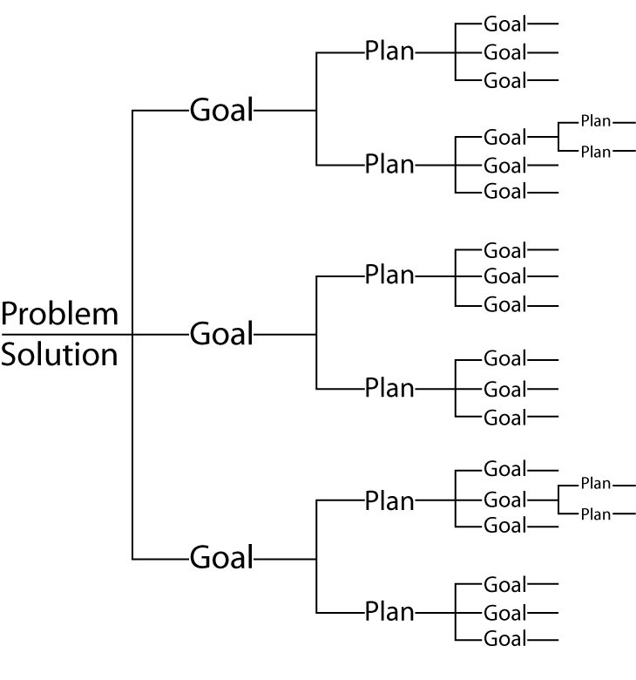
Figure 1

Spohrer and Soloway [1] identified seven components that make up any plan. Novices tend to misunderstand these components. Whereas Soloway et al. [1] used Pascal syntax we use C syntax to describe the same components. We did this simply because all of our data described below uses the C programming language.
The following are the seven components:
- Input: SCANF and FSCANF statements.
- Output: PRINTF and FPRINTF statement, for writing out messages, variable values or data file.
- Init: Initialization type assignment statements that give variables their initial values.
- Update: Assignment (or re-assignment) statement that changes the variable values.
- Guard: Conditionals such as IF statements and the test condition of WHILE, DO-WHILE, and FOR statements are used to determine when a loop will be exited.
- Syntax: Syntactical connectives which delimit the scope of blocks of code. Braces ”{}” are used at the beginning and ending of the program, loop, and conditional statement.
- Plan: An entire plan, possibly composed of many of the foregoing micro-plan components.

The following are four ways that a program error can occur in a plan.
- Missing: The plan component is not present in the program.
- Malformed: The Plan component is present, but it is not correctly implemented.
- Spurious: The Plan component is present, but should not be.
- Misplaced: The Plan component is present, but in the wrong place in the program.
Figure 2 pictorially shows the goal and plan relationship as developed by Segelman [7].
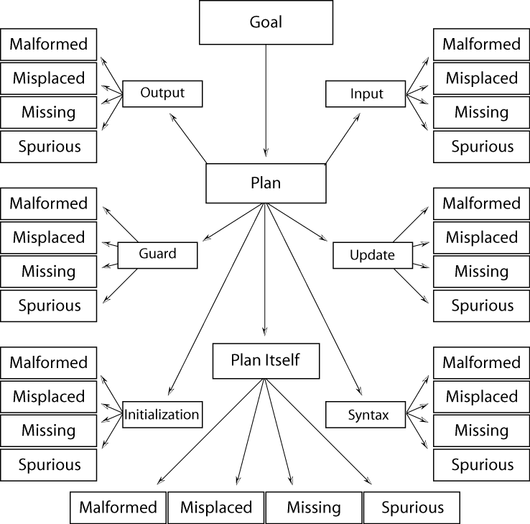

3. Intermediate Programmers

As mentioned in the Introduction, limited research has been done on intermediate level programmers [1,2,3,4]. The goal of this research is to find out whether this or a similar error classification scheme could apply to the study of intermediate student programming errors.

We define an “Intermediate Programmer” as a programmer who, as a rule, no longer makes simple novice errors. The intermediate programmer is supposed to have some programming experience and an understanding of concepts such as program syntax, arguments, debugging, algorithms and structures. A typical exam question for this level student will address topics such as nested loops, arrays, recursion and functions.

4. Data Collection and Analysis

We first used a GAP solution tree to analyze data to help classify intermediate programmer errors. We then studied exam papers from a number of different CIS 15 classes. We reviewed student code and answers in detail. We hope that this research will be beneficial to educators for future reference.

Problem 1

Write a function sum( ) that takes 3 parameters: the call sum( g, i, j ) should return g(i)+…+g(j), where i and j are ints, and i<=j. You may define new types if you wish.

Figures 1-3 outline three solution plans commonly chosen by students who attempted this problem.
Goals
G: Input
G: Loop
G: Output
G: Calc-Sum
G: Output
G: Calc--Sum
G: Loop
G: Input
G: Input
G: Guard
G: Output
G: Calc-Sum-Recursion
G: Input
G: Loop
G: Output
G: Calc-Sum
G: Output
G: Calc--Sum
G: Loop
G: Input
G: Input
G: Guard
G: Output
G: Calc-Sum-Recursion
Figure 1.1
int sum ( int (g) (int), int i, int j)
{
int accumulator =0; int x;
for ( x = i ; x < = j; x + + )
accumulator += g( i );
return accumulator;
}

Figure 1.2
int sum( int (g) (int), int i, int j)
{ int sum=0;
while ( i < = j ){
sum+= g ( i ) ;
i ++ ;
}
return sum;
}

Figure 1.3
int sum(int (g) (int), int i, int j)
{ int s=0;
if(i>=j)
return g(i);
else
return g(i)+ sum(g, i+1, j);
}

The solution of this problem includes the following four goals:

- INPUT: Get information from parameters g, i, and j.
- LOOP: The FOR LOOP or WHILE LOOP is used to go through the result of function g from integer i to j.
- CALC-SUM: Sum up all the elements from the result of function g.
- OUPUT: Return a final value for CALC-SUM.
Figure 1.3 shows a plan where students chose a recursive step. This is in effect a combination of LOOP and CALC-SUM. We included student errors in the recursive step in Table 1.1 under CALC-SUM.

The goals LOOP and CALC-SUM may have the following plan components:
1. LOOP: Initialization, Guard, and Update.
2. CALC-SUM: Initialization, set the sum to zero before executing the WHILE-LOOP or FOR-LOOP. Then it accumulates the values from function g and stores the total in the variable called sum.

Table 1.1 Statistic Table:

23 students answered this question.
Total errors 49
 | Init | Input | Guard | Update | Output | Syntax | Plan | Total
Malformed
Input | 1 | 13 |  |  |  |  |  | 14
Loop |  |  | 1 |  |  |  | 1 | 2
Calc-Sum | 2 |  |  |  |  | 3 | 5 | 10
Output |  |  | 1 |  | 5 |  |  | 6
Misplaced | No errors in this category
Missing
Input |  |  |  |  |  |  | 1 | 1
Loop |  |  |  |  |  |  | 4 | 4
Calc-Sum |  |  |  |  |  |  | 5 | 5
Output |  |  |  |  | 1 |  | 4 | 5
Spurious | Goals Input/Output had no errors
Loop |  |  |  |  |  |  | 1 | 1
Calc-Sum |  |  |  |  |  |  | 1 | 1

Interpretation

This is a good question to test student’s conceptual understanding of loops and function prototypes. The program contains three parameters g, i, and j. All parameters are of type integer. According to the question, g is a function and i and j are also integers. The function sum is used to sum up all results from function g and then return the sum of g(i)+…+g(j) to the main program. The function “g” can be any function such as square, factorial, exponential and so on. Figure 1.4 shows a simple example of g as a square function.

Figure 1.4
int g (int x )
{
return x*x;
}

There were only five students who answered this question and got all correct answers. Most students had problems coding a function prototype with functional parameters. According to Table 1.1 eight students got the correct answer for implementing the prototype, but fifteen other students made errors. Such errors were classified as the malformed Goal: INPUT. Since many students did not realize that g was a function, many of them treated g as an integer.
Ten students had problems achieving the goal of CAL-SUM with MALFORMED errors. Five students used the recursive solution of Digure 1.3. They all incorrectly implemented their plan for the goel CALC-SUM-RECURSION; three students had syntax errors, and two made initialization errors.
More than three students did not implement a plan on the goals: LOOP, CALC-SUM, and OUTPUT which was classified as an error of MISSING. It showed that these students were not aware of the plans needed to solve this problem.
Many students used a FOR-LOOP plan to achieve their goal of LOOP. Some of them used a WHILE LOOP approach. Figures 1.1 and 1.2 show two different plans that achieve this goal. There were four students who used another plan to solve this problem, which was using a plan for recursive functions. One of the correct solutions for this problem is shown in Figure 1.3. Unfortunately, no one implemented the recursive function correctly. Students made errors related to the goal CALC-SUM-RECURSION in their programming plan. The plan of the recursive function they coded was a merge plan, which combined the RECURSION goal and the CALC-SUM goal. Most student programmers made mistakes when they used a merged plan for coding.

Problem 2

Write: int Kdigit(int n, int k) that returns the kth digit of a number n where Kdigit(415,0) returns the right-most digit 5 and Kdigit(415,2) returns 4.

Figure 2.1 shows one correct solution used by students whereas Figure 2.2 shows a typical incorrect solution.

Figure 2.1
G: INPUT
G: GUARD
G: OUTPUT
CALC -RECUR
INPUT
GUARD
OUTPUT
CALC
LOOP
G: INPUT
G: GUARD
G: OUTPUT
G: CALC -RECUR
G: INPUT
G: GUARD
G: OUTPUT
G: CALC
G: LOOP

Kdigit(int n, int k)
{
if( k= =0 )
return (n%10);
return Kdigit( n/10, k-1);
}

Figure 2.2 shows an incorrect solution.

Figure 2.2
Kdigit(int n, int k)
{
if( n/10= =0 )
return n;

for ( int i=0; i<n; i++)
n=n/10;
return n%10;
}

The solution of this problem includes the following four goals:

- INPUT: Get information from parameters n and k.
- GUARD: IF statement is used to determine whether to stop or continue the function recursively.
- OUTPUT: Stop the recursion and return a final result from the recursive function.
- CALC-RECUR: This is a main body of the recursive call and performs the calculation.

Twelve students answered this question. There were only 2 errors. One error was a missing CALC-RECUR goal and the other was a malformed GUARD goal.

Interpretation

The aim of this program is to find the k^{th} digit of a number n. If k is zero, the function returns the right-most digit number of n. If k is one, the function will return the second digit number of n and so on. This question is used to test students’ recursive thinking.

A recursive function is one in which calls itself. Most intermediate programmers often use recursive functions to evaluate certain types of mathematical functions. Therefore, this is a good question for studying intermediate programmer errors.
Below is a table to show the output of a four-digit number using the function Kdigit( ).

N | K | Output
1234 | 0 | 4
1234 | 1 | 3
1234 | 2 | 2
1234 | 3 | 1

Most students did a good job on this question. Ten students determined the correct answer using a recursive function. Two students did not receive full credit due to minor mistakes. Most of the students used the solution shown in Figure 2.1 as their answer. One student developed another plan for the LOOP goal to solve this problem as shown in Figure 2.2. This student used one IF-statement and a FOR-LOOP; but the programming plan was applied to this problem incorrectly. The FOR-LOOP plan could not create a function for a recursive call.

Problem 3
Write the function int RecSum(int n) that sums up the values of all digits of n. If the sum of the digits is smaller than 10, return it; otherwise return RecSum of the computed sum.
Ex. RecSum(99991)->RecSum(37)->RecSum(10)=>return 1

Figure 3.1 shows one correct solution used by students, whereas Figure 3.2 shows a typical incorrect solution.

G: Input
G: Loop
G: Guard
G: Calc
G: Output
G: Recur
Figure 3.1 (One possible solution)
int RecSum(int n)
{
int sum=0;
while(n>0) {
sum+=(n%10);
n=n/10;
}
if (sum<10)
return sum;
return RecSum(sum);
}

Figure 3.2 (Incorrect Solution)
int RecSum( int n)
{ int sum=0;
if (n==0) return sum;
sum =(1+RecSum(n/10));
if (sum<10)
return sum;
return RecSum(sum);
}
The solution of this problem includes the following six goals:

- INPUT: Input experiment data for the parameter n.

- LOOP: Process multiple records of information. If n/10 is equal to zero, the program will exit the while loop.

- CALC: This goal is to calculate the sum of every single digit number.

- GUARD: The guard is used to protect against invalid data. Variable sum must be less than 10 (a single digit number), in order to exit the recursive call.

- OUTPUT: Exit the recursive call if the sum is a single digit and return the sum.

- RECUR: When the sum is not a single digit number, recursive call will continue to process and pass parameters of sum to int ReSum(int n) again.
Table 3.1 Statistic Table:
12 students answered this question.
 | Init | Input | Guard | Update | Output | Syntax | Plan | Total
Malformed | Goal Input had no errors
Loop |  |  |  |  |  |  | 2 | 2
Calc |  |  |  |  |  |  | 3 | 3
Guard |  |  | 4 |  |  |  |  | 4
Output |  |  |  |  | 2 |  | 1 | 3
Recur |  |  |  |  |  |  | 3 | 3
Misplaced | Goals Input/Loop/Calc/Recur had no errors
Guard |  |  | 1 |  |  |  |  | 1
Output |  |  |  |  | 1 |  |  | 1
Missing | Goals Input/Guard/Output had no errors
Loop |  |  |  |  |  |  | 5 | 5
Calc |  |  |  |  |  |  | 1 | 1
Recur |  |  |  |  |  |  | 1 | 1
Spurious | Goals Input/Calc/Output/Recur had no errors
Loop |  |  |  |  |  |  | 1 | 1
Guard |  |  | 1 |  |  |  |  | 1
Total errors 26

Interpretation

Problem 3 also relates to the use of a recursive function as shown in Figure 3.1, but it is a little more complicated. This program calculates the sum of all digits of the number and then determines whether to exit or continue. The recursive call is determined by a single IF-statement. The program uses both a recursive step and a single FOR-LOOP or WHILE-LOOP. Most students had problems developing two separate plans to solve the two goals.
Many students developed their plan for goal GUARD at the beginning of the program, which was an incorrect plan. Most of them missed a plan for achieving the goal LOOP. Five students received full credit and seven had bugs in their code. According to the statistical table, eight students had problems in planning the goal LOOP, producing MALFORMED, MISSING, and SPURIOUS errors. Four students made mistakes in goal: GUARD. Some students used more than one IF-statement to develop a recursive call; however, their plan still did not achieve the goal of recursion.

Problem 4

Write a short program that accepts a file name as a command line argument. The file is assumed to contain ten integers. Have the program print out the median of these ten numbers.

Figure 4.1 shows a correct solution to this problem.

G: Loop1
G: Input
G: Output
G: Loop2
G: Guard
G: Swapping
G: Openfile

Figure 4.1
main(int argc, char *argv[])
{
FILE *infile;
int n[10], i, j, temp;
int num=10;
infile=fopen(argv[1],"r");

for ( i=0; i<num ;i++)
{
fscanf(infile,"%d",&n[i]);
printf(" %d ",n[i]);
}
for( i=0;i<num-1; i++)
for ( j=i+1; j<num; j++)
if(n[i]>n[j])
{
temp=n[i];
n[i]=n[j];
n[j]=temp;
}
printf("\n%d is a median\n",n[5]);
fclose(infile);
}

The solution of this problem includes the following seven goals:

- OPENFILE: A file pointer, infile, is created by data type FILE*. Using a function, fopen, tells the operating system the name of the file or argument from command-line.
- INPUT: Get information and data. The function fscanf allows the program to receive input data from the file.
- LOOP1: Read data from the pointer infile and write to array a[i] by using a single loop.
- LOOP2: A nested loop is used to compare adjacent elements of the array a[0],a[1]……a[n].
- GUARD: This determines whether or not two elements need to be swapped.
- SWAPPING: Exchange the content of array elements.
- OUTPUT: Return the median of 10 elements.

Table 4.1 Statistic Table:
30 students answered this question.
 | Init | Input | Guard | Update | Output | Syntax | Plan | Total
Malformed | Goals Loop1/Input had no errors
Openfile | 1 | 1 |  |  |  | 1 | 4 | 7
Sg: Header |  |  |  |  |  |  | 1 | 1
Sg: D-F-T |  |  |  |  |  |  | 1 | 1
Sg: Fopen |  |  |  |  |  |  | 2 | 2
Loop2 |  |  |  |  |  |  | 3 | 3
Guard |  |  | 1 |  |  |  |  | 1
Swapping |  |  |  |  |  |  | 1 | 1
Output |  |  |  |  |  |  | 1 | 1
Missing
Openfile |  |  |  |  |  |  | 1 | 1
Sg: Header |  |  |  |  |  |  | 2 | 2
Sg: D-F-T |  |  |  |  |  |  | 7 | 7
Sg: Fopen |  |  |  |  |  |  | 8 | 8
Loop1 |  |  |  |  |  |  | 5 | 5
Input |  |  |  |  |  |  | 9 | 9
Loop2 |  |  |  |  |  |  | 8 | 8
Guard |  |  |  |  |  |  | 8 | 8
Swapping |  |  |  |  |  |  | 9 | 9
Output |  |  |  |  |  |  | 5 | 5
Spurious | Goals Openfile/Loop2/Swapping/ Output had no errors
Loop1 |  |  |  |  |  |  | 1 | 1
Input |  | 1 |  |  |  |  | 1 | 2
Guard |  |  |  |  |  |  | 1 | 1
Total errors 83

Interpretation

For this problem, a full score is 21 points, the lowest score is 0, and the average score is 15. The aim of this question is to test student implementations of the program header, the file opening function fopen, fscanf and the sorting algorithm.
In order to help classify specific errors we have developed the following three step plan for the Goal OPENFILE: HEADER, D-F-T and FOPEN. This plan has three subgoals: SG: HEADER, SG: DEF-FILE-TYPE and SG: FOPEN (the prefix "SG" is for subgoal).

P: HEADER-DFT-FOPEN

01. main(int argc, char *argv[]) SG:HEADER
02. FILE *infile; SG: DEF-FILE-TYPE
03. infile=fopen(argv[1],’r’); SG:FOPEN

Eleven students received full credit on this problem. Table 4.1 shows that there were a total of 83 programming errors for this problem. There were 29 errors made when students achieved the goal of OPENFILE. Many students did not know how to develop a plan for declaring a file type and opening a file; therefore they created many MISSING and MALFORMED errors on the subgoals of OPENFILE.
Moreover, about 31 out of 83 errors came from goals LOOP2, GUARD, and SWAPPING. Those errors were classified as MISSING which means students had difficulties finding a median by using a sorting algorithm, e.g. bubble sort, selection sort and so on. However, the question did not mention whether the input numbers were sorted or unsorted. Some students received full credit without using a sorting algorithm. They calculated the median by first summing up the fifth and the sixth elements. They then divided by two. A number of students wrote a sort( ) function; they sent parameters to the sort( ) function and then found a median from the middle element of the array. Two students had another plan to achieve the LOOP2 goal by combining WHILE-LOOP and FOR-LOOP to implement the nested loop.

Conclusion

In this paper we present the error analysis of a few intermediate-level C programs. We applied the theory of GAP trees to semantically analyze these program errors. A few simple observations can be made. Educators must be very careful in their problem description and presentation. Students are easily confused by the language used. Students also seem to be confused by nested loops and recursion. Errors of this type may define the boundary of what distinguishes novice programmer errors from intermediate level programmer errors.

Our work is only a first step. We hope that our initial work in classifying and testing programs written by intermediate-level programmers will spur additional research. This and further research could be an invaluable aid to instructors in both first and second-level programming courses.

References
- Soloway, E. Spohrer, J.C., and Pope, E. (1985). A Goal/Plan Analysis of Buggy Pascal Programs. Norfolk: World Conference on Computers in Education.
- Spohrer, J.C, Soloway, E. (1986). “Novice Mistakes: Are The Folk Wisdoms Correct?” Communications of the ACM. Volume 29 (pp.624-632)
- Johnson, W. Lewis and Soloway, E. (1984). PROUST: Knowledge-Based Program Understanding. (Technical Report 285). New Haven, CT: Department of Computer Science, Yale University.
- Spohrer, J.C and Soloway, J.C. Alternative to Construct-Based Programming Misconceptions. Communications of the ACM.
- Hoxha, Altin. (May, 2000). Analysis and Classification Of Intermediate Programmer Errors. Computer Information Science 60.1 Senior Research Project
- Minzer, David. (May, 2001). A Study of Intermediate Programming Errors. Computer Information Science 60.1 Senior Research Project.
- Segelman, Stan. (May, 2003). A Continuing Study of Intermediate Programming Errors. Computer Information Science 60.1 Senior Research Project.
- Kopec, Danny, Minzer, David, and Segelman., Stan (2003) The Study of Intermediate Student Programmer Errors. (in revision) for the International Journal of Human-Computer Studies.

