CIS 1115 Hypothetical Final Java Version A PART I 70 points
1. Assume that you run the program shown below. Assume that the file "bowlingscores.txt" contains these values: 265 170 375 -1
- What output will be sent to the screen?
- What output will be sent to the file "results.txt"?
import java.io.*;
public class FileQuestion {
public static void main(String[] a) {
int score, sum = 0;
Scanner fin = new Scanner(new File("bowlingscores.txt"));
PrintStream fout = new PrintStream(new File("results.txt"));

fout.println("new game"); score = fin.nextInt();
while (score >= 0){
fout.print("You have " + score); if (score > 300)
fout.println(" and it is not accepted");
else {
fout.println(" and it is accepted");
sum = sum + score;
}
score = fin.nextInt();
}
fout.print("done"); fout.println("the sum is " + sum);
fin.close(); fout.close();

}
---------------------------------------------------------------------------------------------------------------------
2a. Write a method called sortem which has two parameters. One parameter is an array of doubles, and the other parameter is the number of elements to process in the array. The method should sort the array of doubles into ascending order. The method should not return a value.
b. Assume that you have an array named vals that has 75 elements, and an int k containing a positive integer less than or equal to 75. Use the sortem method you wrote above sort the first k values of the array and write some code that prints, one to a line, the values that were not sorted.
---------------------------------------------------------------------------------------------------------------------
3. The method contains shown below is designed to search the array arr (which holds n elements) for an element that is equal to value.
The method should return true if there is such an element in the array, and the method should return false if there is no such element.
However, the method shown below has a number of mistakes.
boolean contains(int arr[], int n, int value) { for (int i = 1; i <= n; i++)
if (arr[i] == value)
return true;
else return false;
}
- There are 3 mistakes in the method. For each mistake in the code shown above, underline the mistake. Then explain in 1-2 sentences what the problem is. You must explain each of the 3 mistakes.
- Rewrite the entire method so that it does work correctly, as described above.
---------------------------------------------------------------------------------------------------------------------
4 Write a method called eliminateFirst, that does the following:
The method has one parameter which is a (possibly empty) string. The method returns a copy of the string with the first character (if it exists) eliminated, along with every other appearance of the first character. So
eliminateFirst("Cha-Cha Chatanooga") returns "ha-ha hatanooga" eliminateFirst("bababa babarbara-ann") returns "aaa aarara-ann" eliminateFirst("x") returns "" eliminateFirst("") returns ""
---------------------------------------------------------------------------------------------------------------------
- Consider the following excerpt from the Java API Documentation:
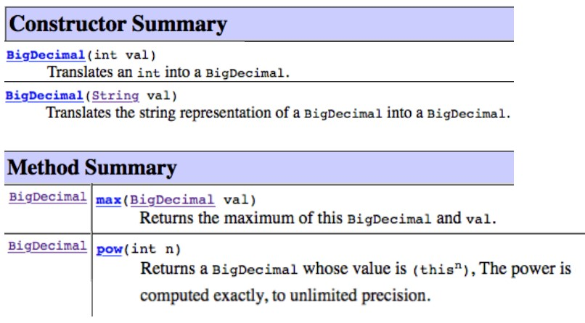
Write some code that:
  - Declares 3 BigDecimal reference variables, bd1, bd2, bd3.
  - Uses a Scanner to read in an int and a String, storing them in variables n and s respectively (these variables have already been declared).
  - Makes bd1 refer to a BigDecimal object constructed from n.
  - Makes bd2 refer to a BigDecimal object constructed from s.
  - Makes bd3 refer to a BigDecimal object that is the cube (3rd power) of the greater of the BigDecimal objects refered to by bd2 and bd2.
---------------------------------------------------------------------------------------------------------------------
- Show what is printed by the following program.
import java.io.*;
public class LoopQuestion {
public static final int N = 7;
public static void main(String[] a) {
Scanner in = new Scanner(System.in); int[] a = new int[N], b = new int[N];
for (int i=0; i<N; i++) { a[i] = in.nextInt(); b[i] = i%2==0?2*i:i+1;
}
dump(a,b,1); mangle(a,b,N-1); dump(a,b,2); mangle(b,a,b.length); dump(a,b,3);
}
void mangle(int[] x, int[] y, int j) {
System.out.print("round "+j+": ");
for (int i=0; i<N; i++) { a[i] = in.nextInt(); b[i] = i%2==0?2*i:i+1;
}
}
void dump(int[] x, int[] y, int j) {
System.out.print("round "+j+": ");
for (int i=0; i<N; i++) { a[i] = in.nextInt(); b[i] = i%2==0?2*i:i+1;
}
}
}
----------------------------------------------------------------------------------------------------------------------

7. A run in an array of integers is a sequence of 2 or more integers each of which is one more than the previous. So if an array contains these values: 5 6 3 9 11 12 13 14 -5 -4 -3 -1 18 2 it contains three runs: 5,6 and 11,12,13,14, and -5,-4,-3.
Write a method named getLongestRun that receives as an argument an array of integers and that returns an array of integers. The array that is returned contains a copy of the longest run. In the above example the longest run is 11,12,13,14 and so an array containing exactly those values would be returned.
---------------------------------------------------------------------------------------------------------------------
PART II (6 pts) For parts 1 - 5, perform the requested conversions:
- 101011 (base 2) to base 10 Answer: ________________
- A9 (base 16) to base 10 Answer: _______________
- 1101101 (base 2) to base 16 Answer: ________________
- 46 (base 10) to base 2 Answer: _______________
- F6 (base 16) to base 2 Answer: ________________
- Perform the following addition of two binary (base 2) numbers. Your answer should be a number in binary.
101 + 101 = ? Answer: _______________
---------------------------------------------------------------------------------------------------------------------

PART III (24 points)
Write a complete Java program, including comments in main and in the other methods (comments will be worth 2 points) to do the following:

- Write a method called readData. The method has three parameters, an integer k and two arrays of integers. The method will read k lines of data, each of which contains two integers. For each line of data, the method will store the first data value read in the first array, and the second data value read in the second array. The method will print the original data values as they are read in. The method will not return a value.
- Write a method called lessThanLast which has one parameter, an array of integers p. The method will determine how many elements in array p are less than the last element in the array. The method will return this value. As an example, assume the array holds: 31 12 8 1 4 8; the values 1 and 4 are less than the last value, which is 8. Therefore, the method returns 2.

- Write a method called changeonearray which has three parameters, one integer k, plus two integer arrays (alpha and beta) of size k. The method will set each of the first k elements of the alpha array equal to 5 times the corresponding value in the beta array. For example, if alpha[0] started out holding 3, and beta[0] held 7, then alpha[0] will be changed to 35 (which is 5 times 7), and so on. No value is returned.
Write a main method that calls these three methods as follows:
- First the main program reads in a header value m, which will indicate the size of the set of data; it creates the necessary arrays then to hold the data. Then the main program calls the method readdata (see part 1) to read a set of data containing m lines of input (each line contains two data values) into two integer arrays which the main program calls numb1 and numb2.
- Then the main program calls the method lessthanlast (see part 2) to determine how many elements of the numb1 array are less than the last element. The main program will print the value returned by the method.
- Finally, the main program calls the method changeonearray (see part 3) to modify the values stored in the numb1 array. After the method finishes, the main program will print the new values stored in the numb1 array.
Assume all input comes from the keyboard, and assume all output goes to the screen.

