CISC 3600 "Game Programming"
Flash Group Questionnaire
Name: ___________________________________________________________________

- On a scale of 1-10, circle the number corresponding to your programming abilities in FLASH CS4 or CS5.
1 2 3 4 5 6 7 8 9 10
What's Flash? The universe is a program.
I wrote it, using Flash.

- On a scale of 1-10, circle the number corresponding to your general confidence in your abilities as a game programmer (mechanics of games).
1 2 3 4 5 6 7 8 9 10
Newb Neo

- On a scale of 1-10, circle the number corresponding to your general confidence in your abilities as a game designer (dynamics of games).
1 2 3 4 5 6 7 8 9 10
I find "go-fish" confusing. 4D chess anyone?

- On a scale of 1-10, circle the number corresponding to your general confidence in your abilities as a game artist (aesthetics of games).
1 2 3 4 5 6 7 8 9 10
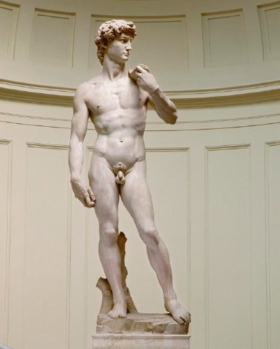
- Is there anyone in the class that you would like to work with? Is there anyone in the class you would prefer not to work with? Please explain.

